The purpose of this project is to see if there is a way of improving vehicle safety, and finding out what steps to take to insure less injuries due to vehicle collisions in Seattle. By deep diving into the metadata provided by the Government of Seattle-SPD & recorded by Traffic Records: vehicle collisions through the years (2010-present) we can find the reasons of how the injuries due to vehicle collisions came to be.

<https://s3.us.cloud-object-storage.appdomain.cloud/cf-courses-data/CognitiveClass/DP0701EN/version-2/Metadata.pdf>

The data describes all types of Collisions by geographical location, street location, the description of the location, the severity of the accident, the collision type, the amount of people injures, the date etc. Everything one needs to know about collisions in Seattle can be found in this data. To see the excel spreadsheet:

<https://s3.us.cloud-object-storage.appdomain.cloud/cf-courses-data/CognitiveClass/DP0701EN/version-2/Data-Collisions.csv>

Unfortunately there is a lot of unnecessary information for what we are deep diving into, so after manipulating the data in python and digging into the types of collisions and the point of impact:

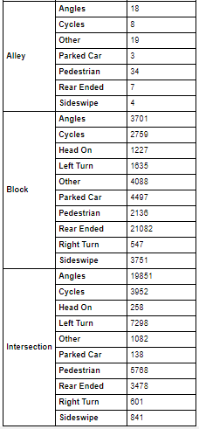

We can see from the data above that the highest injuries due to collisions are from driving in an Alley- Pedestrian. On a typical Block the highest collision is rear ending. At an intersection angles are the highest in injury.

The CDC states:

Almost half (47%) of crashes that resulted in a pedestrian death involved alcohol for the driver and/or the pedestrian.1 One in every three (33%) fatal pedestrian crashes involved a pedestrian with a blood alcohol concentration of at least 0.08 grams per deciliter (g/dL), 17% involved a driver with a blood alcohol concentration of at least 0.08 g/dL, and some fatal pedestrian crashes involved both.  
*Risk Factors:  
-*Higher vehicle speeds increase both the likelihood of a pedestrian being struck by a car and the severity of injury.  
-Most pedestrian deaths occur in urban areas, at non-intersection locations, and at night.

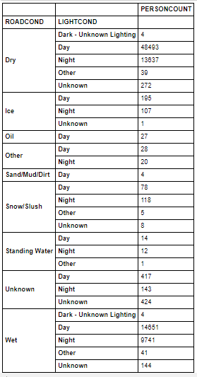The CDC is correct by far, non-intersection (alley) areas have the most pedestrians being injured. About 29% of all collisions are rear-end collisions and are also the top leading for injury and fatalities, and the most common causes for it are distracted driving and speeding. Intersection angles are common from constant lane changes and turns.

Once diving into the types of collision, the next step was to dive into whether the types of road conditions and visibility were cause to injuries.

The data is clear that the road and light conditions are not a factor to the injuries due to collision. Even when road conditions were dry the most injuries were caused during the day, same as when the road conditions were wet.

One of the most valuable tools to use is the folium library. Using the coordinates provided, we can pinpoint locations of where majority of injuries happen due to collisions.

Using the first 300 entries since the data is so large, mapped out we can easily observe where most injuries happen.

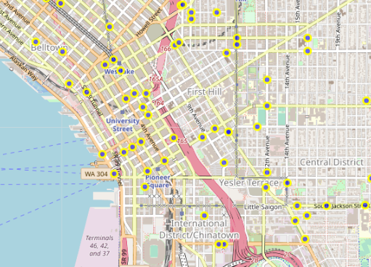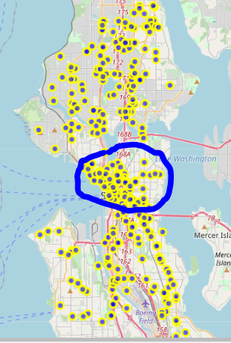As we can see to the left the majority of injuries due to collision is dead centre of Seattle. Zoomed in, as seen above we can see that majority of the injuries due to collision are just North of the International District/Chinatown.

By adding markers to our folium map, we can see which vehicle collisions are happening in different areas.

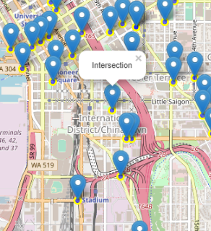

As we can see the main collisions causing injury in the city are within the International District, majority of the collisions are in fact Block, or Intersection collisions.

In conclusion, in order for the people of Seattle to avoid injury while driving a vehicle, I believe that the government of Seattle should regularly monitor the highways for drinking and driving, and speeding. Clearly by adding more stop lights as well as speed bumps we can avoid more accidents, however distracted driving is the number one cause for injuries due to vehicle collisions. By implementing an app on people's phone's for them to automatically be on silent when driving would be the best solution.